Alamo Area Council, B.S.A.

COPE

Emergency Procedures

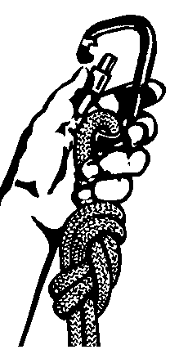

Staffing:

COPE courses in the Alamo Are Council (McGimsey Scout Park, Bear Creek Scout Reservation, or Mays Family Scout Park) should always be operated with two or more trained facilitators present who are members of the Alamo Area Council COPE Committee. At least one of these should have current Red Cross First-Aid and CPR Certification. This follows the BSA requirement for a Two Deep Leadership, provides support for a thorough COPE experience for participants, provides the minimum of manpower for emergencies, and generally complies with COPE Standards. The facilitators on the course are always the first line of defense against incidents. They must follow BSA, COPE, and local rules and enforce them upon the participants.

All incidents involving injuries or near misses on the COPE course must be documented on a COPE Course Incident / Close Call Report. They should also be reported to the Alamo Area Council Staff and COPE Staff. If there is a need for emergency personal, dial 911

Minor Incident:

First, secure all participants and then asses the severity of the incident. If simple first aid can be performed within the capabilities of the on-site staff and the first aid supplies are available, treat the wound and fill out a COPE Course Incident / Close Call Report. During this time, the participants should be under the direction of the assistant facilitator or one of their adult leaders. After treatment, an assessment may then be made as to weather the participant should continue activity. Decide on the side of caution; if in doubt, call the person’s parents or family and the BSA or COPE staff.

Close calls fall in this category of assessment also. If no injury of any sort has occurred, but the circumstances were present for one to happen, fill out a Course Incident / Close Call Report immediately. In either of the above cases, contact the Council Staff and the COPE Director soon after the activity.

Major Incident:

Any injury involving the likelihood of scarring, delayed recovery, loss of function, or cause for professional treatment is considered major. Assess the severity and extent of the injuries and then send the co-facilitator to call parents, family, or EMS. Administer CPR or first aid treatment from the first aid supplies. If parents or family cannot be reached and it is judged that the injury is life-threatening, call EMS. If parents or responsible adults are present and the participant is conscious and able to walk and the injuries are not life-threatening, participants may be directed to the hospital or medical facility of their choice.

Any incident in which there is the hint of threats or litigation by the participant, parent, family member, or visitor, regardless of whether there is injury, should treat as a major incident and the Course Incident / Close Call Report should be filled out carefully and completely and Council and COPE Staff contacted. (See also sections on Liability and Filling out the “Course Incident / Close Call Report”.)

The fire department should also be contacted in severe cases where rescue is needed, especially combined rescue and medical treatment, such as a heart attack on a high element.

Staff Contacts:

One of the following staff members should be contacted as soon as possible, preferably in the listed order:

Event COPE Director
Camp / Park Ranger
COPE Professional Staff Representative
Scout Executive

A valid contact must be to the person and not just a message on an answering machine / voice mail. In the unlikely event the activity is during the weekend and not during work hours, call the Scout Office number on the Emergency Contact Sheet.

Non-Medical Emergencies:

In the event of emergencies which are not immediately medical, such as fire, weather, or disorder, the Co-facilitator should remove the participants to the Ranger’s house. The primary facilitator should first attend to contacting emergency help by phone. After contacting emergency help, contact the Council and COPE staff. Record the required information for the COPE Course Incident / Close Call Report.

Liability:

Every one involved can be liable – the Council, the C.O.P.E. Staff, and all facilitators involved. Volunteer or professional status makes no difference. If we have rules (we do, COPE Standards and local rules) and follow them, we reduce the likelihood of incidents and of litigation if one occurs. COPE and rope courses in general, have a very good reputation for safety and freedom from incidents.

For negligence to be proved, four elements must be proved; not just one, all four.

- There must be a duty owed by the person in charge to the participant to provide a safe environment. We all owe COPE participants this duty.
- The duty owed must be breached by not performing the standard of care required for that activity and environment. This includes both acts of commission and omission.
- There must be proximate cause: the injury must be the result of the act or failure to act.
- There must be actual damage sustained as the result of the injury.

To provide a standard of care, three things must be provided in addition to having skill and reasonable actions in what you are doing:

- Supervision – maintain control of the group at all time while the group is on site.
- First Aid Knowledge – not just simple first aid, but knowledge specific to the activity you are doing. The COPE Standards cover these pretty well.
- Emergency and Disaster procedures - This document is meant to serve as our emergency and disaster procedure.

The participant has the responsibility to recognize the possible risks associated with COPE (or any other high adventure) activity. This information should be provided to him or her in the COPE Information Sheet and acknowledged by the participant and his or her parent, if he or she is a minor, by signing the Medical Information / Consent form before participation in COPE.

Filling out the COPE Course Incident / Close Call Report

Copies of the COPE Course Incident / Close Call Report should be available in the COPE Storage area. The assistant facilitator should begin documenting the needed information on the form as soon as possible. Do not wait until the incident is over! Be sure you know where the forms are before the activity begins. It is best if you have a form and writing instrument on the course with you at all times.

The incident form should have five items on it.

- The sequence of the activity - Did the injury occur in the beginning, middle, or end on the activity? What preceded the injury, what instructions were given, had the activity been practiced?
- Where did the incident occur? Where were the participant, facilitators, and witnesses? Draw a diagram. What were each doing?
- Exactly what was the injured person doing and how did the incident occur?
- Ask the injured participant what happened and what he or she was doing. Write down any admission by the injured that he or she was not following directions, or that he or she did something wrong, or failed to do something he or she was supposed to do.
- List the procedure followed and the first aid rendered. What emergency service was called? Which medical facility was the injured taken to? Document the times. List only what was done

DO Not give your opinion; keep the information factual.

Show care in dealing with the injured participant, they family, and fellow participants. Visit the injured frequently after the incident.

Acceptable Rescue Techniques

Prevention:

The COPE course is designed to reduce the likelihood of having to rescue by going to the participant. Most such rescues are the result of a participant climbing with a self-belay such as rabbit-ears or crab-claws. A fall from such an apparatus may be unrecoverable, even if the climber is not injured, if he or she is in such a position that he or she cannot raise themselves back to a climbable position on a wire or pole. This situation should only exist at the COPE course when facilitators are climbing to rig or unrig an element. Never climb alone. Another facilitator should always be within sight, watching the climber’s actions to be sure he or she does not put themselves in a position of carabineers unhooked, and to be off aid if a fall should occur.

There can be areas in the COPE Course where belay transfers may be made:

- Between the High Multivine and the Burma Bridge (McGimsey)

- Between the Burma Bridge and the Zipline (McGimsy)

- Between the High Multivine and the Zipline (Bear Creek)

The belay transfers should always be made by COPE Staff member while secured on the platform. Always connect the participant to the second element before disconnecting the participant from the first element belay system.

Extension Ladder Rescue:

If there is a ladder that can extend and reach the high elements, then lean the extension ladder against the cable or other part of the element. This would allow the participant to clear any obstruction and climb down the ladder, continue on the element, by lowered on belay, or a facilitator could climb to the participant to aid in rescue. If fire truck rescue aid is called, a ladder or the use of a boom operated bucket is the most likely models of rescue.

Rope Ladder / Etreir Rescue:

The Alamo Area COPE courses have both a caving ladder and an etrier which can be used for rescue. The caving ladder is kept rolled up in the COPE storage area except when in use on one of the high course activities. The etrier is kept with the emergency bag and should be on site whenever high course activities are being performed. There are several ways to rig one of these devices to affect the rescue of an able-body, but stranded participant.

A caving ladder or etrier can be attached to a belay cable, if available, by a rapid link or carabineer and sent to the participant either by a rescuer or by a haul line from the ground. Either of the devices can also be attached to a cable with a steel carabineer by a rescuer and sent to the participant by a haul line or rescuer. It must be placed on the proper cable in such a manner that the participant can both reach it from his or her position, and be able to raise himself or herself to clear any obstruction or get to a cable or pole. This above method is to aid a participant to a secure position or be lowered down.

Cut-Away Rescue (LAST RESORT)

If all other attempts to free up the belay system and return the participant safely to the ground have failed, then the last option is to climb up and cut the person down. This should be only performed by a qualified staff member. If you have not performed this procedure before, do not try it during an emergency; call the fire department. It is hard to imagine a situation in which the participant could not be lowered down on belay, but it is impossible to imagine all possible scenarios to which a frightened participant may resort. The procedure is as follow:

The rescuer ties a figure eight on a bight knot in one end of the rescue belay rope and attaches the eight to his harness with the aluminum carabineer. The rescuer then weaves the rope through the rescue eight close to the knot and attaches the rescue eight to his or her harness with the steel carabineer. Attach 4 or 5 aluminum carabineers to the primary carabineer attached to the belay rope. Attach one of the spectra cord (#1) loops to the belay rope near the figure eight on a bight using a prusik knot. Add an aluminum carabineer to the loop (#1). Install the second spectra cord (#2) loop to rescuer’s harness with a aluminum carabineer. Add a second aluminum carabineer to the loop (#2). Meanwhile the co-facilitator prepares the other end of the rescue belay with a second rescue eight or ATC belay device for belaying the rescuer and participant. A static or dynamic anchor should be arranged to belay two persons. These preparations should ideally be ready in the rescue bag, but should not be left prepared permanently.
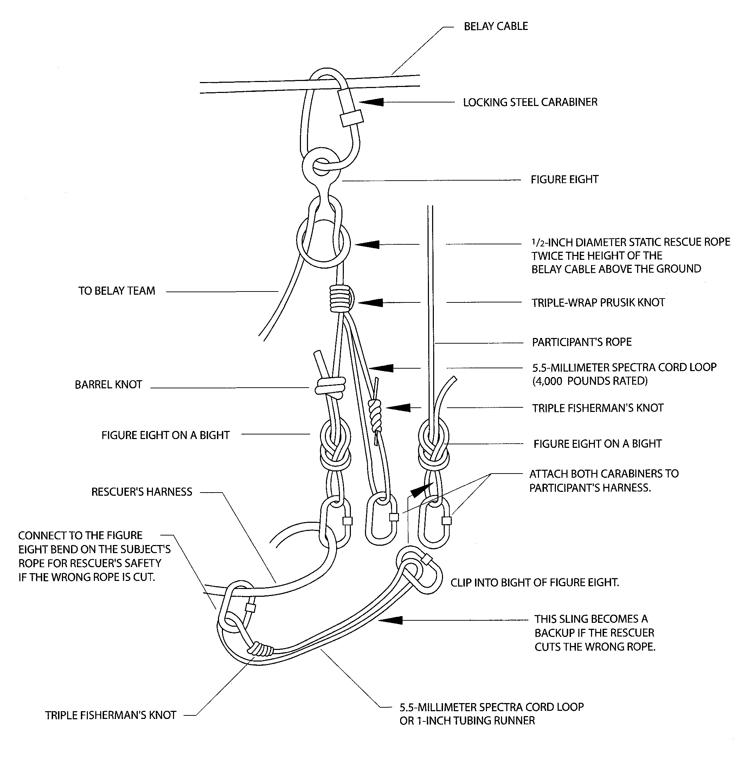
The rescuer climbs the element with crab claws to a cable above the participant, attaches the steel carabineer with the rescue eight to the cable and informs the ground belayer that he or she is going “on belay”. The rescuer then disconnects from the crab claw and moves out onto the element to a position directly above the participant. Approach the participant so that he or she is to the less dominant hand side of the rescuer. The belayer lowers the rescuer according to the rescuer’s instructions to a position just slightly above the participant: don’t get too low! When the rescuer is in the right position, he or she attaches the chain of carabineers as short as possible to the participant’s primary carabineer or harness (there should not be any slack between them), attach spectra cord carabineer #1 to the participant harness, attach the spectra loop carabineer #2 to the participant’s loop of the figure eight on a bight knot. Keep in mind that, depending upon the circumstances, it may be possible, if necessary, to begin rescue breathing from this position.

Once the rescuer is securely hooked to the participant with carabineer locked, he or she wraps one arm (less dominant hand) around the participant and uses the other hand to get the knife, surgical scissors, or other cutting device. (Prepare with the knife / scissors on the dominant hand side.) Once the participant’s rope is cut, the ground belayer, with the aid of anchors, should lower the pair to the ground. If the rescuer cuts his or her own belay rope, there will be two to rescue, if there are enough people and equipment to do it.

Rescue bag: (one for each High Element used)
- 1 static belay rope, ½ inch diameter, bright orange, 150 feet long
- 12 aluminum auto-locking carabineers, “D” or “Oval”
- 3 steel auto-locking carabineers, “D” or “Oval”
- 1 steel rescue figure eight
- 1 aluminum rescue figure eight
- 1 Steel Trolley
- 1 set of Crab claws or Personal Fall Arrest System
- 2 spectra cords, 5.5 mm, 20 feet long
- 1 tubular webbing, 1 inch, 30 feet long
- 1 tubular webbing, 1 inch, 12 feet long
- 1 tubular webbing, 1 inch, 6 feet long
- 1 rescue knife, pocket knife, or scissors
- 1 pair of pliers
- 2 pairs of leather palm gloves
- 1 backpack bag

